Chapter 16, Solution 42.

Given the circuit in Fig. 16.65, find i(t) and v(t) for t > 0.

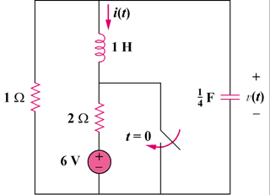
12 V

Figure 16.65
For Prob. 16.42.

Solution

Step 1. First we need to find the initial conditions. Since the inductor becomes a short and the capacitor becomes an open circuit, all the current flows through the 1 Ω and 2 Ω resistors or i(0) = –12/3 = –4 amps and v(0) = 4x1 = 4 volts. Next we need to convert the circuit into the s-domain and solve for V and I. Once we have done that, we can perform partial fraction expansions and convert back into the time domain.

4/s

s

1 Ω

4/s

+
−

4/s

V

[(V–0)/1] + [(V–4/s)/(4/s)] + [(V–0)/s] – [4/s] = 0 and I = [(V–0)/s] – [4/s].

Step 2. [(1+(s/4)+(1/s)]V = [(s²+4s+4)/(4s)]V = 1+4/s = (s+4)/s or
V = (4s+16)/[(s+2)²] = [A/(s+2)]+[B/(s+2)²] where As+2A + B = 4s+16 and
A = 4 and B = 16–2A =8. I = [4/(s(s+2))]+[8/(s(s+2)²)]–4/s
The partial fraction expansion is straight forward for the first and third terms, but the second term takes a little work. 8/(s(s+2)² = [a/s]+[b/(s+2)]+[c/(s+2)²] or as²+a4s+a4+bs²+b2s+cs = 8 or a = 2, b = –2, and c = –4.

Thus, I = [2/s]+[–2/(s+2)]+[2/s]+[–2/(s+2)]+[–4/(s+2)²]–4/s = –[4/(s+2)] – [4/(s+2)²] and we finally get,

v(t) = [4e^{–2t} + 8te^{–2t}]u(t) volts and

i(t) = [–4e^{–2t} – 4te^{–2t}]u(t) amps.

